**Pics of 6 Ducks**

|  |  |  |  |
| --- | --- | --- | --- |
|  | **Daffy** | **Yellow Duckies** | **An Angry Mallard** |
| **NON DISNEY DUCKS** | Daffy |  |  |
|  | **Donald** | **Huey Dewey and Louie** | **Scrooge McDuck** |
| **DISNEY DUCKS** |  |  |  |

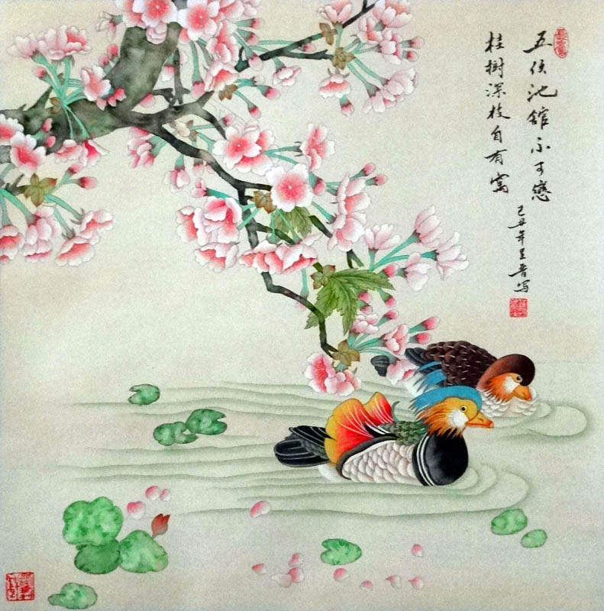

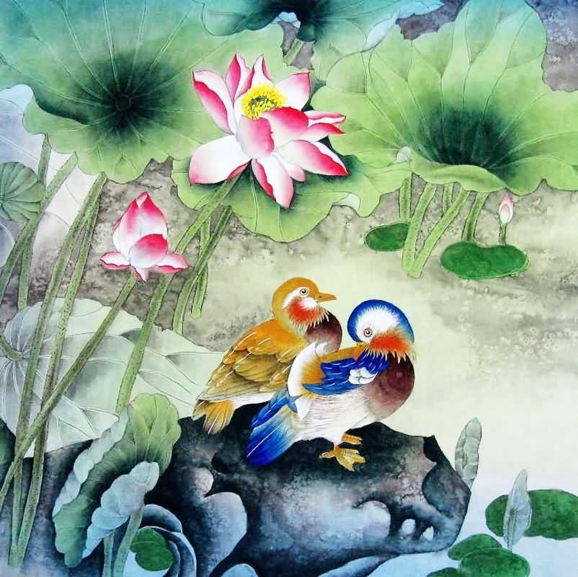

**Duck Poems**

**THE DUCK**  
by **Ogden Nash**

**-** <https://silverbirchpress.wordpress.com/2014/05/17/the-duck-poem-by-ogden-nash/>

Behold the duck.  
It does not cluck.  
A cluck it lacks.  
It quacks.  
It is specially fond  
Of a puddle or pond.  
When it dines or sups,  
It bottoms ups.

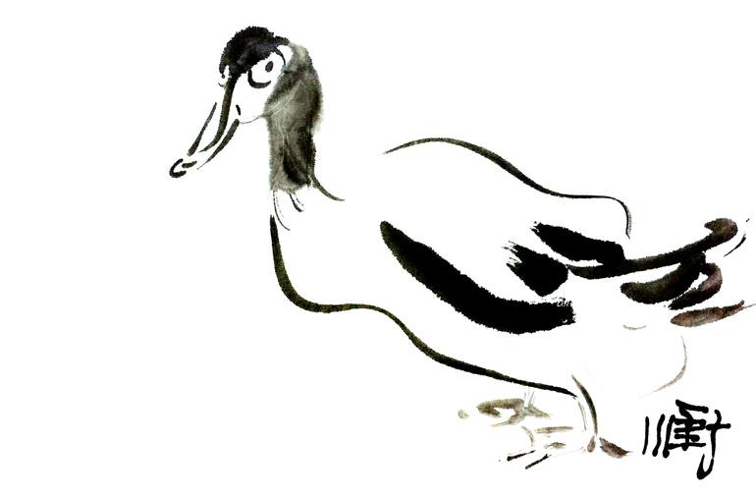

***Wood-Duck* by Isaac McLellan -** <https://discoverpoetry.com/poems/duck-poems/>

In May-time, when the lilac-plumes  
Droop from the branch their purple blooms;  
When chestnuts clap their leafy hands,  
And every bud with joy expands;  
When in the moist, sequester'd nooks  
Of woods is heard the call of brooks,  
The wood-duck builds its downy nest  
Secure from prowling schoolboy's quest.

The swampy, shallow creeks they haunt,  
Where thick woods o'er the waters slant,  
Whose interlacing branches make  
A dusky evening in the brake;  
And there their little nests are made  
In hollow mossy log decay'd,  
Or where the woodpecker had bored  
The crumbling bark to hide his hoard,  
Fast by the stream whose ripples beat  
The tree-roots of their close retreat.  
Most beauteous of all the race  
That skim the wave or soar in space,  
With plumage fairer than the rays  
The bird-of-paradise displays,  
A mottled purple gloss'd with green,  
All colors in the rainbow seen;  
No tropic bird of Indian skies  
May rival thy imperial dyes.  
Least wary of all fowl that wing  
O'er salty bay or inland spring,  
They haunt the pond whose reedy shore  
Extendeth by the farmer's door,  
Or rivulet whose waters trill  
Their melodies below the mill;  
And here the ambush'd gunner lies  
To gather in his lovely prize.